Farmgate biosecurity – People
This document is part of the standard operating procedures (SOP) for porcine epidemic diarrhoea (PED) and is identified as SOP 4.
People present one of the greatest risks for introducing and spreading disease on pig units, making effective farmgate biosecurity essential.
Anyone who goes onto a pig unit – from staff to visitors – can carry diseases on their boots, clothes, skin, hair or even in their nose.
PED is most readily transferred in infected pig faeces, but it can potentially be spread in aerosols as well. The virus particles are extremely infective and only a tiny amount of infected faeces can cause disease.
This document is written for the porcine epidemic diarrhoea virus (PEDv), but good biosecurity protocols are equally relevant to all pig diseases and should be adhered to as strictly as possible.
The document has two aims:
- To prevent PEDv from entering a unit.
- To prevent PEDv from leaving a unit where there is a conﬁrmed breakdown.

General biosecurity principles for people
All staff and visitors should follow these core biosecurity practices:
- Stop all unnecessary visits onto the farm – if possible, conﬁne visitors to an oﬀ‐site oﬃce
- Ensure staﬀ and visitors are aware of the risks they pose and how to limit them
- Minimise visitor contact with pigs

Vehicles and parking
Vehicle access and parking arrangements should be managed to minimise contamination risk, including:
- Do not allow any unnecessary vehicles on site
- Provide a signposted staﬀ and visitor parking areas outside the unit perimeter
- Try to ensure that parking areas are hard-surfaced and well‐draining
- Sweep and disinfect parking regularly
- Request and check that vehicles arrive clean and free of manure and organic material, including in the footwells
- Provide effective disinfection facilities for all personnel, vehicles, and equipment entering or leaving the site, including hand and boot sanitation, Personal protective equipment (PPE), and vehicle wheel cleaning facilities.

Staﬀ
Farm staff play a key role in maintaining biosecurity and should follow these requirements:
- No farm staﬀ should have any contact with pigs (including pet pigs) or pig manure outside of their employment; this should be included in employment contracts
- Farm staﬀ who have livestock other than pigs at home must arrive at work clean (such as hands and hair) and in clean clothes and footwear that has not been exposed to their own livestock
- All staﬀ should be provided with (and must wear) outerwear and boots that are left on the unit
- Staﬀ who have returned from travelling overseas (especially North America and Asia) should notify the farm manager before returning to work if they have had contact with any pigs, including wild boar
- Staﬀ should be made aware that it is illegal to bring meat products onto the premises

Visitors
Visitor access must be strictly controlled to reduce disease risk. The following practices should be followed:
- Conﬁne visitors to an oﬀ‐site oﬃce where possible
- If essential to enter the farm, for example, maintenance or vet visit, ensure visitors adhere to speciﬁed period of ‘pig freedom’
- The period of ‘pig freedom’ will vary depending on the health status of your unit – discuss with your vet. It should be speciﬁed in advance and is usually:
  - At least 48 hours of (overnight) freedom from pigs and pig manure
  - 72 hours in the case of nucleus breeding herds
- Visitors should arrive in clean clothes and footwear
- Visitors must sign in using a visitors’ book, including the date and details of last pig contact
- The manager must be conﬁdent of the visitor’s credentials and low biosecurity risk before permitting entry
- Ideally visitors should shower in (including hair) and move into a ‘clean’ area to change into unit-speciﬁc clothes, including protective outerwear and footwear
- At the very least, visitors must wear only farm‐supplied outer clothes and boots (or wrapped disposable overalls)
- The Danish/bench entry system is an excellent alternative when a shower is not available (refer to the Danish/bench entry procedure)
- Any equipment and tools required by the visitor and brought onto the farm must be visibly clean and, where possible, should be disinfected or covered with a new disposable plastic bag
- Visitors should not bring any food onto the farm
- Minimise visitor contact with pigs where possible

Incoming deliveries, equipment, semen, etc.
Supplies and deliveries must be managed carefully to prevent disease introduction.
The following measures should be applied:
- Discuss your biosecurity protocols with your suppliers; make it clear what risks they may pose to you and other pig farms they visit
- Remember, you are the customer and have the right to demand good biosecurity from your suppliers
- If you are not satisﬁed with the cleanliness of your suppliers, you should refuse entry to your farm
- Ideally a secure, clean, watertight delivery box should be situated outside the farm perimeter (consider thermal requirements for medicine and semen deliveries)
- Make sure you know the health status of the source stud for semen deliveries and review the information regularly
- Minimise the number of suppliers – a single source is preferred
- Delivery vehicles and personnel should not enter the farm or make direct contact with farm staﬀ, for example, shaking hands
- Dispose of any packaging outside the farm
- Routinely use disinfectant wipes on incoming goods

Danish/bench entrance
The Danish/bench entry system (Figure 1) provides a controlled method for entering and leaving the farm, helping to reduce the risk of disease introduction and spread.
It should be used as follows:
- This method can be used where a walk‐through shower facility is not available
- It is based on a single designated entrance onto the farm which all personnel (staﬀ and visitors) must pass through on entry and exit
- The system can also be applied at individual building entrances as required
- It only works if everyone follows all the steps all the time

When entering the farm/building
Follow these steps when entering the farm or building:
- Always enter through the Danish entry
- Reach inside the door to collect some disposable boot covers and put these on before entering
- Remove outer coats, other personal belongings and hang on pegs
- Step into the dry disinfectant boot tray and sit on the bench
- Remove shoes, leaving them on the boot tray on the dirty side
- Without touching the ﬂoor, swing legs over to the clean side
- Disinfect hands with hand sanitiser
- Put on farm overalls, boots and gloves kept on the clean side of the entry
- Enter the production area

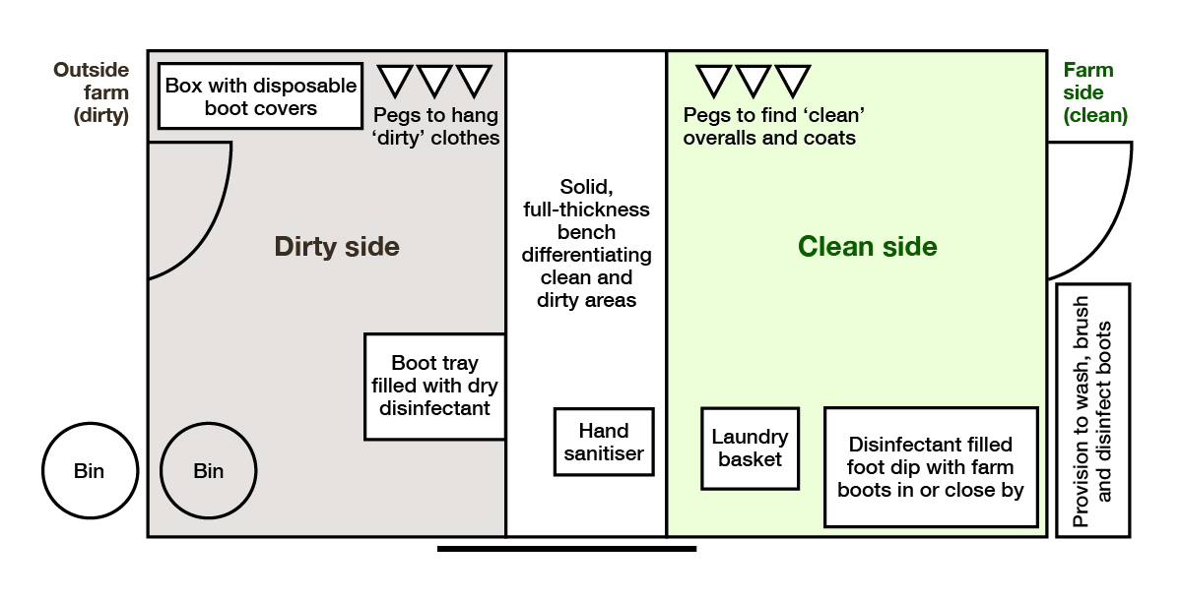
Figure 1. Diagram showing the floorplan of a pig unit Biosecurity Entry Point

The diagram shows a Danish/bench entry system divided into a ‘dirty’ side (outside farm area) and a ‘clean side’ (farm area), separated by a solid bench. On the dirty side are disposable boot covers, pegs for outdoor clothing, a dry disinfectant boot tray and bins. A hand sanitiser is positioned at the bench. On the ‘clean’ side are farm overalls, a laundry basket and a disinfectant foot dip for farm boots. The layout ensures people change clothing, footwear and sanitise their hands before entering or leaving pig production areas.

When leaving the farm/building
Follow these steps when leaving the farm or building:
- Always leave through the Danish entry
- Thoroughly clean, brush and disinfect boots before entering the Danish entrance
- Once inside, remove farm boots and leave in the disinfectant foot dip on the clean side
- Remove farm clothing and hang on pegs on the clean side
- Disinfect hands with hand sanitiser or wash them thoroughly with soap and water if available
- In sock feet, swing legs over the bench to the dirty side
- Put on outside shoes (still with disposable covers)
- Collect any belongings and exit
- Once outside, remove disposable boot covers and place in outside bin
- Both sides of the bench must be kept clean

Summary points for reducing the risk of spreading PEDv for farm visitors
- Contact farm manager prior to your visit
- Only visit if essential
- Ask about the farm’s biosecurity protocols and adhere to them
- Ensure your car is clean of manure and organic material (outside and especially the footwells)
- Park in designated visitor car park
- Wear clean clothing and footwear
- Enter the farm through the designated entry point (ideally Danish/bench entry system)
- Sign the visitors’ book
- Change into boots and overalls speciﬁc to that farm (consider disposable overalls)
- Do not enter restricted access areas without permission
- Do not have direct contact with animals without permission

Explore further resources on biosecurity
These sources provide additional information on biosecurity practices for livestock:
- Biosecurity guidance on our website – ahdb.org.uk/knowledge-library/biosecurity
- All SOPs available on our website – ahdb.org.uk/PEDv
